## Steps to prepare report

|  |  |
| --- | --- |
| Step | Description |
| 1 | Open drive:  <https://drive.google.com/drive/u/6/my-drive> |
| 2 | Download **sale** data:   1. Open sale from the drive 2. File > Download> Microsoft Excel (.xlsx) 3. Save file > OK 4. File name (salemonthday) eg. **sale0301** 5. Save |
| 3 | Download **stock** data:   1. Open sale from the drive 2. File > Download> Microsoft Excel (.xlsx) 3. Save file > OK 4. File name (stockmonthday) eg. **stock031** 5. Save |
| 4 | 1. Open products_mpl > 2. products_mpl.Rproj> 3. Open sale.Rmd 4. Click on Knit |
| 5 | 1. On the sale.pdf report > Save as > File name (reportmonthday) eg. report0301 2. Go to folder> Report> Open report031.pdf> Print |
| 6 |  |

## Image

Step 1

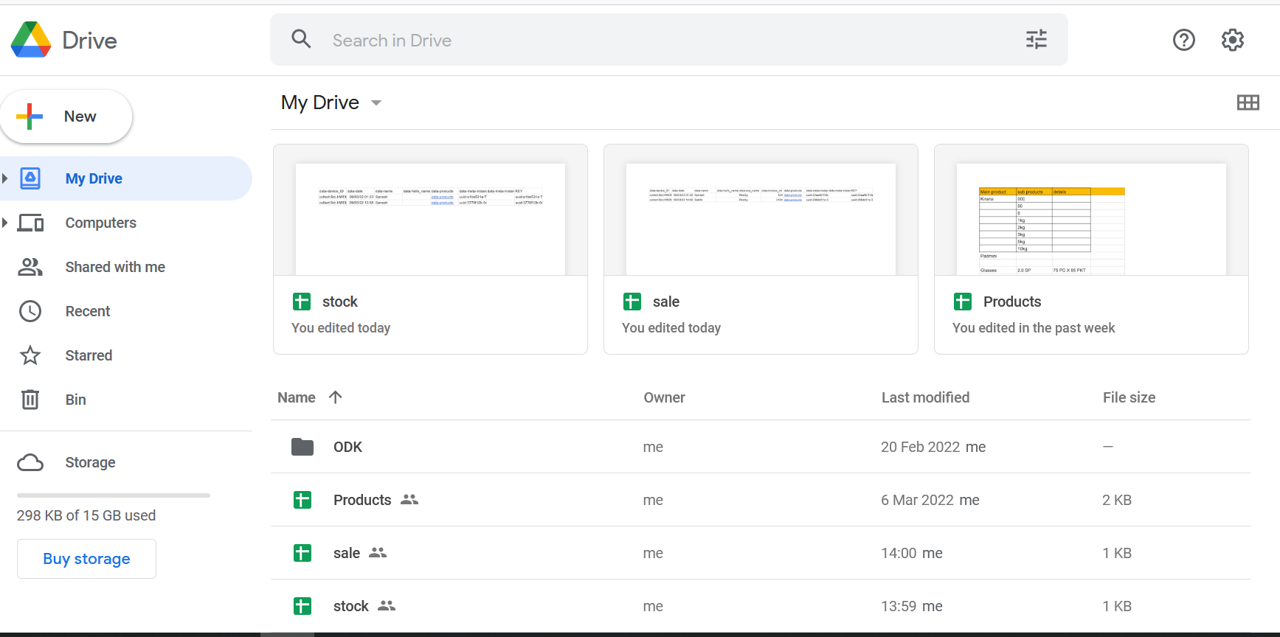

Step 2 a&b

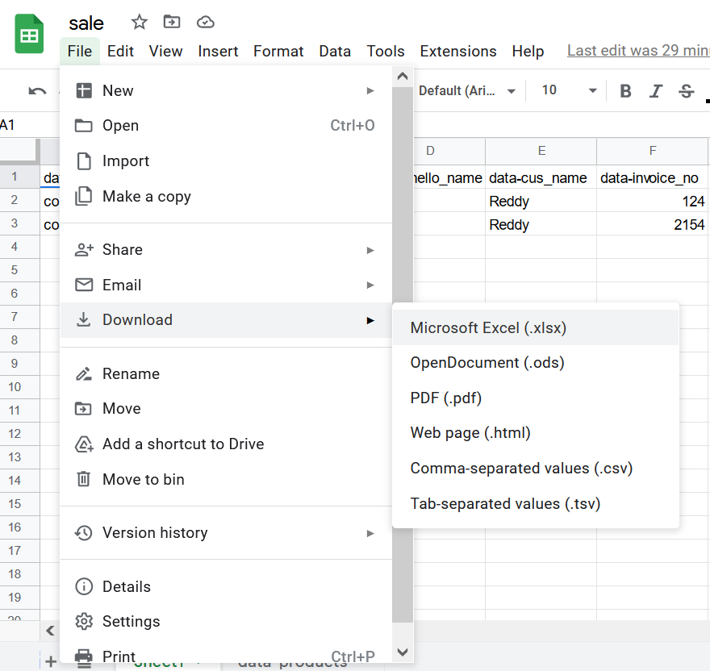

Step c

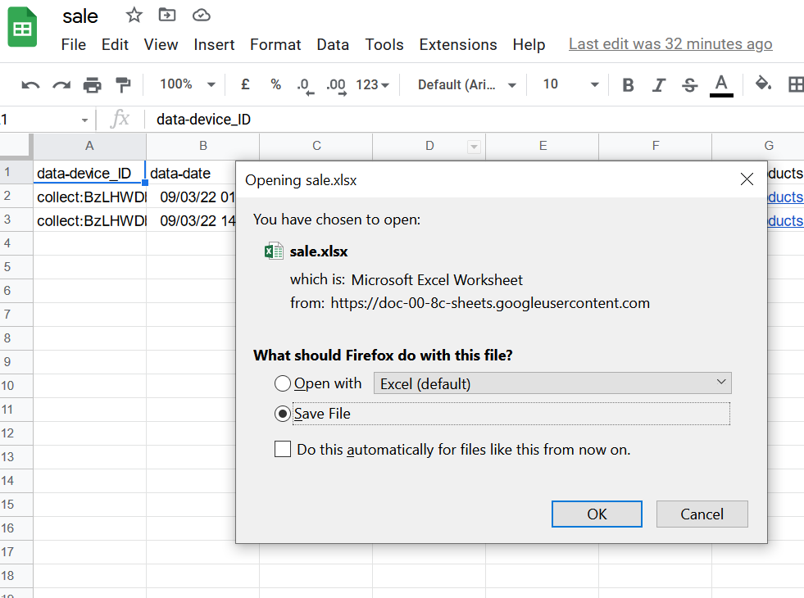

Step d & e

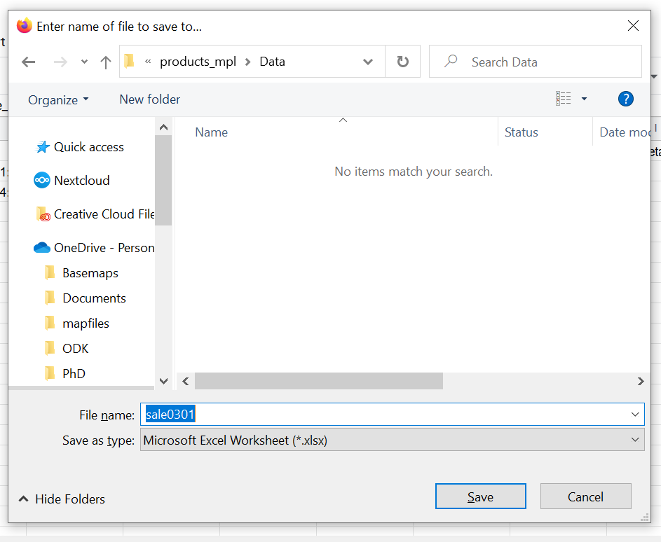

Step 4 a

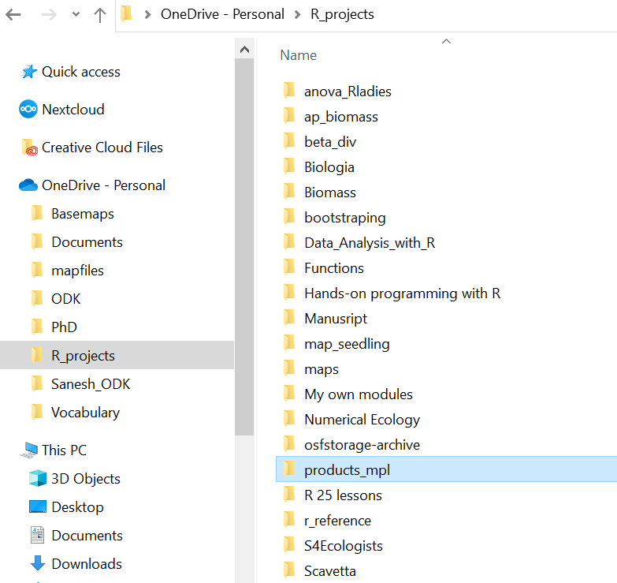

Step 4 b

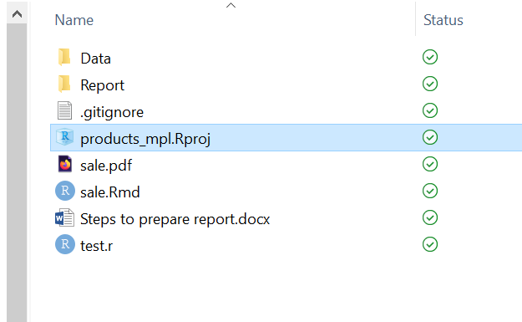

Step 4 c

sale. Rmd

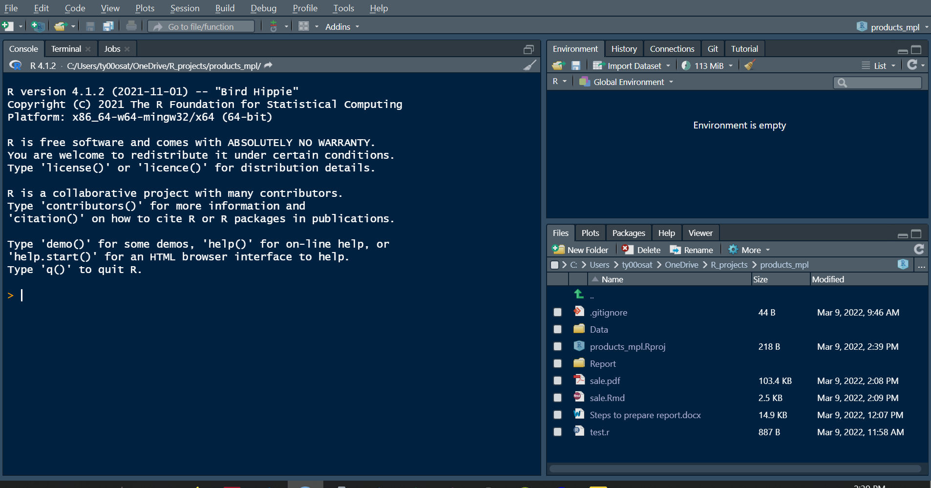

Step d

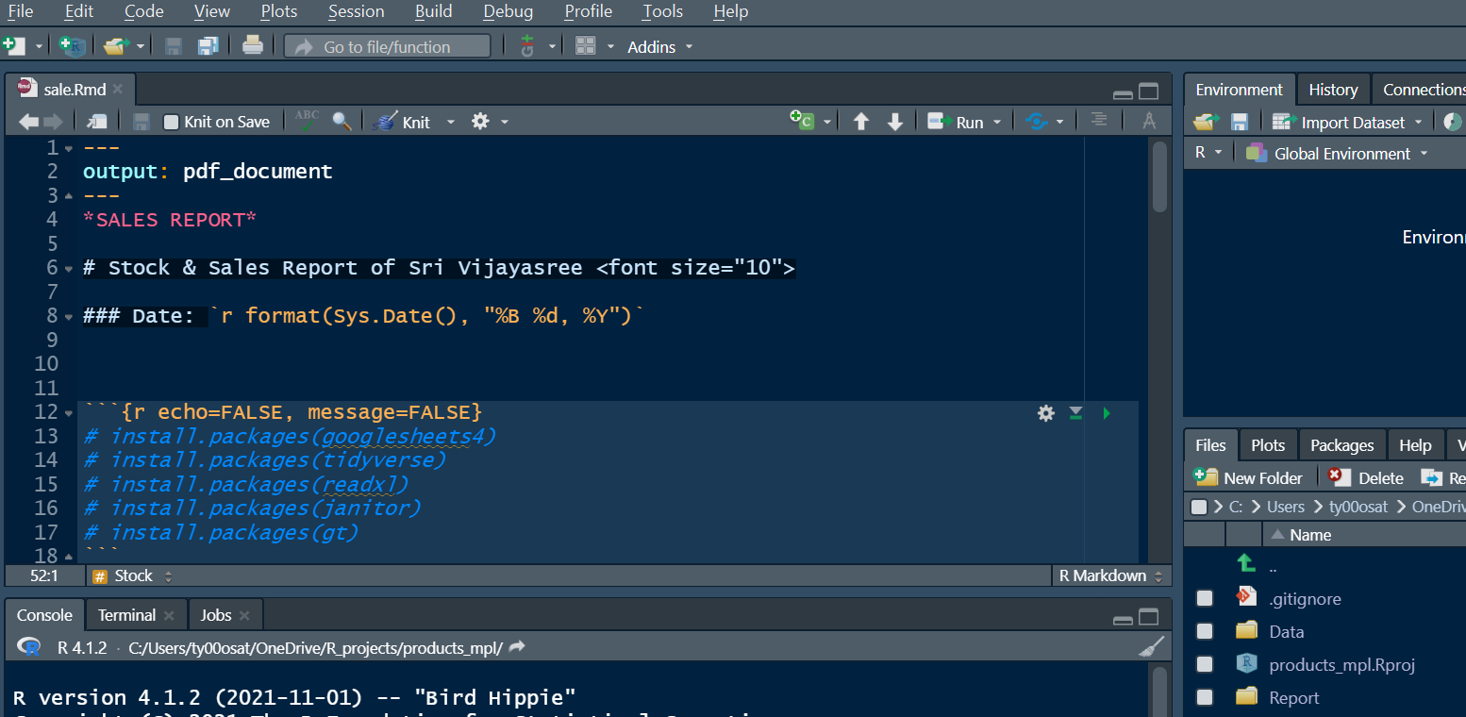

Step 5 a

